|  |  |
| --- | --- |
|  | **FPT ACADEMY INTERNATIONAL**  **FPT – APTECH COMPUTER EDUCATION** |

Lady’s Haven Shop

Instructor: Le Mong Thuy

Batch: T1-1810-E0

Team: Group 4

Student:

|  |  |  |
| --- | --- | --- |
| No | Full name | ID |
| 1 | Mai Anh Vu | Student1151441 |
|  |  |  |
| 3 | Nguyen Dinh Thai An | Student1151446 |
| 4 | Pham Hai Quang | Student985571 |

# Start date: 12/08/2019

**End Date: 17/09/2019**

**This is to certify that**

**Mr./Ms.:**

Mai Anh Vu

Nguyen Dinh Thai An

Pham Hai Quang

**has successfully designed & developed**

Haven Bag shop website

**Submitted by:**

**Mai Anh Vu**

**Date of issue: 12-Aug-2019**

**Authorised Signature:**

**Acknowledgement**

We would like to thank all the team member who has been working hard on completing this project. Special thanks to the team at the faculty for extending their support when we need. A special thanks to Ms. Le Mong Thuy for dedicating herself to helping us completing the project in a professional way.

Finally we would like to thank Aptech for giving us the opportunity to take part in the project so that we know what a project looks like when it comes to real world work project.

Table of Contents

**Part 1…………………………………**6

Sypnosis………………………………..6

Problem Statement…………………………………..6

Customer requirement………………………………..8,

Function flowchart of website……………………………….11

Task sheet review …………………………………..14

**Part 2…………………………………..**10

Entities, ER diagram and Properties……………………………… 16

Table Design………………………………………19

Relationship diagram……………………….24

Site Map………………………………………….25

Task sheet review 2……………………………29

**Part 3…………………………………….**30

Mock of website full screenshot ………………………………………30

Home……………………………………………..30

Admin’s Login…………………………………………… 31

Admin’s Dashboard…………………………………….. 34

Product’s page…………………………….34

Sign up………………………………………….35

Sign in……………………………………..36

User account profile ………………………. 37

Cart page……………………………….37

Task sheet review 3…………………………………38

**Sypnosis**

With the ever increase usage of internet throughout the globe, The needs to move to a new platform is heavily in need. In the old days, people would need to reach out to the authority and get their approval, then they have to look for business storefront that is beneficial when they open their shop. With the social media boom, the second step can totally be scrapped. We aren’t obliged to host our storefront physically anymore. Going digital is the trend and the cost that comes with it are much lower than before.

With that in mind, Lady’s Haven feels that they need to be more competitive within the field. A website with full functionalities is totally needed to drive the traffic and provide more convenience for the customers

**Problem Statement**

Lady’s Haven is an online store that sell various bags for both men and women. Now they need to revamp their website and add more functionalities to be up to current standard. The products are to be listed on the site. Consumers should find it easy to view various bags available with the store. The website must also contain details of locations, a feedback form and the map to the store.

With current standard, the website should be developed using HTML5, Javascript Geolocation and PHP. We will be also administering some famous framework into our site such as Bootstrap and JQuery. The site should work on all leading browser such as Google Chrome, Opera, Firefox, IE, etc.

What we will be looking at are:

**For the administrators:**

* When login with correct account, they’ll be granted access to the admin page with an admin dashboard, where they’ll be able to see the following features:
* A table containing the list of current users registered to the site.
* A tab menu on the left where they’ll be navigating the to many sub-pages.
* They’ll be also granted access to the product page, where the list of all current product will be present. They can also delete the product from the database, or add more products.
* They can see the feedback provided by customers account, as well as replying to said feedback.

**For Visitors:**

* They’ll be greeted with homepage containing information about the shop and some featured products of the day.
* A navigation bar will be present to get them to where they want (contact page, about page, product page, etc.)

**Customer’s Requirement Specification**

**Client:** FPT Aptech

**Project Objective:**

* To rebuild the shop’s website and add functionalities that fit the modern standard (online shopping cart, ordering, managing feedbacks, etc.)
* Revamping the site to be more attractive and easier to look at.

**Site’s Specification:**

* The Home page must have suitable logo and appropriate header (should have images of bags).
* The Home page body will contains information about the store and how the store does business, how long the store has been running and what the store will bring to the customer.
* The site must contain links to navigate through various types of bags, Backpack, etc.
* Site should have different section for men and women, and the bags should be placed accordingly.
* Links of bags should be categorized (backpacks, women’s bag, brand name, etc.)
* Specifications and pricing of bags should be added along with the image.
* There should be section for brand name in the store.
* Feedback must be allowed to be input by the user.
* Site map, Gallery, about us, Queries link, Contact us link must be added. Show the location using maps or GeoLocation API.
* The site should be able to be downloaded as pdf or doc file.
* Advertise section with various facilities provided should be included.
* There will be an about us section at the bottom of every page, included in a way that won’t hamper user experience.
* Cms Admin will manage all features of site.
* Product will be evaluated by customer .
* Site allow customer order and payment with multiple forms.
* Customer can search, sort, show hot products ,...

Input to the system:

**From visitor:**

* Create account with their personal information (optional).
* Select handbags to order.
* Provide their home address if they wish to be delivered to.
* Give ratings and feedbacks to the website as much as possible so they can improve the site functionalities and visualities.
* Review product of web.
* Search handbags on demand
* Edit customer information

**From Admin:**

* Managing products catalog.
* Add/Edit/Delete Product
* Reply Feedback

Output from the system:

**For the visitor:**

* Information about Lady’s Haven.
* Search results.
* Form for sign ups, log ins and feedbacks.
* Website update from the webmaster and admin when there’s one.
* Account management page where they can alter the details if they wish to.
* Ordering and checkout page.
* Payment with multiple methods
* Send email or message (Order number) to customer.
* Display products as required.

**For the admins:**

* Display information related to the current database that are connected to the website (Accounts database, product database, order database, feedbacks, etc.)
* Activity feeds. Anytime a customer updated their account’s details or place an order, a feed is sent to notified the admin that an order was placed by who or someone just edited their account.
* Display the function for manipulating aforementioned database such as deleting or adding.

Hardware requirement:

* Pentium 40Mhz cpu or better.
* 64Mb or RAM or better.

Software requirement:

* Notepad/HTML Editor.
* Dreamweaver.
* IE 5.0/Netscape 6.0

Overall structure of the system:

The websites will be connected to a central server database, where we will store all user’s information (feedback form, registration info, etc.). Visitors can make request to access the details of many our products.

The admin will be controlling the database on whether they’d want to add a product, or perform a review on customer’s account. They will be also replying to feedbacks provided by customer if they can.

**Function Flowchart of the Web Sites**

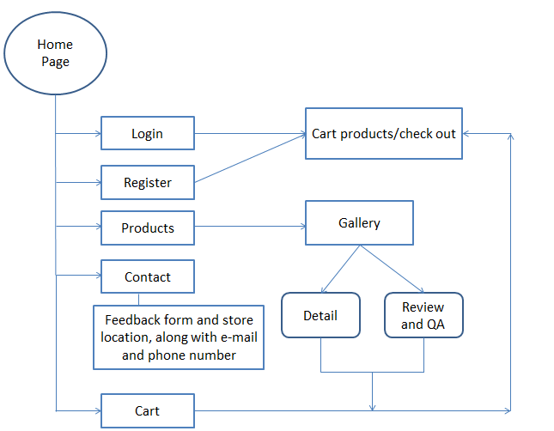

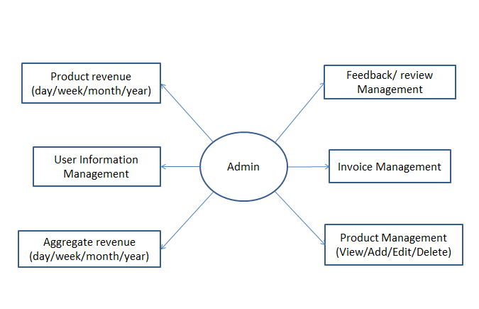

**Description:**

* Home page: Home page will contains information about the store, how we promote our business and how we treat our customer.
* Login: The user can login with the existed credentials, or create new one through Register page. By logging in, they will have the ability to save their products to the cart should they want to buy it at a later time, as products will be saved to the server.
* Products: This will be a showcase for various products, with options for filtering through categories of bags like: Men’s bags, Women’s bag, Brand name, etc. Display by sort by price, by date.
* Contact: This page will contain information for the user to enter such as feedback form. The form will be sent back to the server and the host can revise the user experience based on the feedbacks. Map will also be provided, should the user wish to navigate to the storefront. Shop’s e-mail and phone number will be included as well. Within Contact there will be feedback form for customer to fill in.
* Cart: This page will show all selected item by customer and allow payment
* Admin will manage all feature of site (View Product revenue,...)

**TASK SHEET REVIEW 1**

|  |  |  |  |  |
| --- | --- | --- | --- | --- |
| **No.** | **Description** | **Begin Date** | **Team mate Name** | **Notes** |
| 1 | Problem Statement | 12/08/2019 | Vu |  |
| 2 | Requirement Specification of HavenBagShop.com Website. | Vu |  |
| 3 | DataFlow diagram | Quang |  |
| 4 | Function Diagram of Visitor | Quang |  |
| 5 | Task Sheet | Vu |  |
|  |  |  |  |
|  |  |  |  |
|  |  |  |  |

|  |  |
| --- | --- |
| **Date:** | |
| Signature of Instructor:  **LE MONG THUY** | Signature of Team Leader:  **MAI ANH VU** |

**PART 2.**

**ENTITIES & ENTITY RELATIONSHIP DIAGRAM**

1. **Entities**

Customer

Feedback

Admin

Order

Product

Brand

Order item

Payment

Review

Rating

1. **ER Diagram**
2. **Property**



Admin





Customer ID

Customer telephone

Customer Password



Customer

Customer Email



Customer Name



Customer Address



Product

Product ID

Images



Product Description

Product Name

Product Price

Order Address

Customer Name





Customer ID

Order ID

Date Order





Order Status



Quantity

Product Name

Total

Customer Telephone

Product Price

Product ID

Feedback Id



Customer ID

Feedback Content



Feedback



Reply Content

Reply Date



Feedback Date

1. **Table Design**
2. **Table admin**

|  |  |  |  |  |
| --- | --- | --- | --- | --- |
| **Column Name** | **Data Type** | **Null** | **Key** | **Note** |
| admin_username | varchar(30) | No | Primary key |  |
| admin_password | varchar(30) | No |  |  |

1. **Table customer**

|  |  |  |  |  |
| --- | --- | --- | --- | --- |
| **Column Name** | **Data Type** | **Null** | **Key** | **Note** |
| customer_username | varchar(30) | No | Primary key |  |
| customer_password | varchar(30) | No |  |  |
| customer_name | varchar(50) | No |  |  |
| customer_email | varchar(50) | No |  |  |
| customer_mobile | int(11) | Yes |  |  |
| customer_status | tinyint(4) | Yes |  |  |
| customer_gender | tinyint(4) | No |  | 0: Female 1: Male |
| customer_dob | Date | No |  |  |
| created_date | Timestamp | No |  | current timestamp |

1. **Table customer_order**

|  |  |  |  |  |
| --- | --- | --- | --- | --- |
| **Column Name** | **Data Type** | **Null** | **Key** | **Note** |
| order_id | int(11) | No | Primary Key |  |
| customer_username | varchar(30) | Yes | Foreign Key | Reference to table customer |
| customer_email | varchar(50) | Yes |  |  |
| customer_tel | int(11) | Yes |  |  |
| order_status | Varchar(15) | Yes |  |  |
| payment_method | Varchar(5) | No |  |  |
| delivery_time | Varchar(10) | Yes |  |  |
| delivery_address | Varchar(255) | No |  |  |
| delivery_note | Varchar(255) | No |  |  |
| created_date | timestamp | No |  | Current timestamp |

1. **Table order_item**

|  |  |  |  |  |
| --- | --- | --- | --- | --- |
| **Column Name** | **Data Type** | **Null** | **Key** | **Note** |
| order_id | int(11) | No | Primary Key  Foreign Key | Reference to table products |
| prod_id | int(11) | No | Primary Key  Foreign Key | Reference to table customer_order |
| quantity | int(11) | Yes |  |  |

1. **Table products**

|  |  |  |  |  |
| --- | --- | --- | --- | --- |
| **Column Name** | **Data Type** | **Null** | **Key** | **Note** |
| prod_id | int(11) | No | Primary Key |  |
| prod_name | varchar(50) | No |  |  |
| prod_price | int(11) | No |  |  |
| prod_description | varchar(1000) | No |  |  |
| image | varchar(20) | No |  |  |
| image_2 | varchar(20) |  |  |  |
| Image_3 | varchar(20) |  |  |  |
| Image_4 | varchar(20) |  |  |  |
| quantity | Int(11) | Yes |  |  |
| product_gender | Varchar(10) | No |  |  |
| product_category | Varchar(10) | No |  |  |
| brand_id | Int(11) | No | Foreign Key | Reference to table brand |
| Material | Varchar(50) | yes |  |  |
| Detail | Varchar(50) | Yes |  |  |
| Detail_size | Varchar(50) | Yes |  |  |
| Strap_material | Varchar(50) | Yes |  |  |
| Strap_length | Varchar(50) | Yes |  |  |
| Zip_type | Varchar(50) | Yes |  |  |
| Slot_num | Varchar(50) | Yes |  |  |
| Simple_size | Int | Yes |  |  |
| Style | Int | yes |  |  |

1. **Table feedback**

|  |  |  |  |  |
| --- | --- | --- | --- | --- |
| **Column Name** | **Data Type** | **Null** | **Key** | **Note** |
| feedback_id | int(11) | No | Primary Key |  |
| customer_username | varchar(30) | Yes | Foreign Key | Reference to table customer |
| email | varchar(50) | No |  |  |
| telephone | int(11) | Yes |  |  |
| feedback_details | varchar(300) | Yes |  |  |
| admin_id_reply | varchar(30) | No | Foreign Key | Reference to table admin |
| reply_detail | varchar(1000) | Yes |  |  |
| reply_date | varchar(30) | No |  |  |

1. **Table brand**

|  |  |  |  |  |
| --- | --- | --- | --- | --- |
| **Column Name** | **Data Type** | **Null** | **Key** | **Note** |
| id | int(11) | No | Primary Key |  |
| name | varchar(255) | Yes |  |  |

1. **Table product_rating**

|  |  |  |  |  |
| --- | --- | --- | --- | --- |
| **Column Name** | **Data Type** | **Null** | **Key** | **Note** |
| id | int(11) | No | Priamry Key |  |
| product_id | int(11) | Yes | Foreign Key | Reference to table product |
| customer_id | varchar(255) | No | Foreign Key | Reference to customer_username in table customer |
| rating | int(11) | Yes |  |  |
| Rating_content | Varchar(1000) | yes |  |  |

1. **Relationship Diagram**

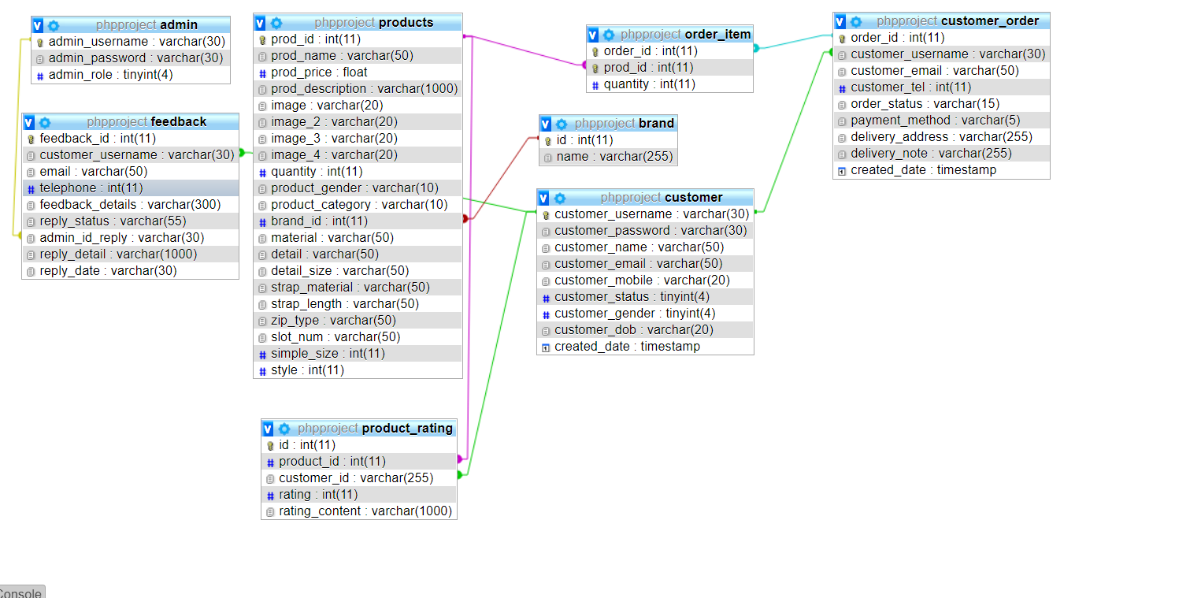

**III. Site Map.**

1. **The visitors’ website: ·**

* **Homepage**:

+ Display some examples of Packs, Backpacks.

+ Present our team.

+ Allow visitors to sign up for membership or log in if they have an account

* **Product**:

+ List types Packs and Backpacks.

+ Sort all products with categories

+ Allow visitors to order any of the products to the shopping cart ·

* **Shopping cart**:

+ List of the products you have order

+ Allow visitors to update or delete their orders

+ Present the form for the visitor to fill in their delivery information

+ Present the bill after the visitor check out ·

* **Contact**:

+ Allow visitors to know about our email and location. ·

+ Allow visitors who are logged in to give their feedback on the services provided by us.

+ Allow visitors to give us feedback even without logging in, with the condition that they have to provide us email.

**Site map the guest website**

Sign up Form

Home Page

Sign up

Log in

Login



Product

Cart

Contact and Feedback



Packs or Backpacks for Male and Female



Select Items



1. **The admin’s website**:

* **Log in**: grant access to admins from us or the webmaster if they provide correct their username, password and account type.
* **Product’s Catalog**: allow admins to view and manipulate the menu of the shop by selecting provided functions (view, create, search, edit, delete)
* **Customer’s Order**: allow admins to keep track of customer orders from the guest website
* **Customer Account Creation**: allow admins to store personal details from customer accounts and change the status of their account
* **Customer feedback**: allow admins to view customer feedback sent from the services of our shop and offer replies to them
* **Customer review list:** admins can see a list of reviewed product and review whether they should delete or let a review be kept.

**Site Map The admin website**

Create new admin account



Login

Admin Account



Edit account

Admin

Home Page





Product

Order

Customer Membership

Feedback



Reply Feedback

Edit or Delete

Product

Add new Product

**TASK SHEET REVIEW 2**

|  |  |  |  |  |
| --- | --- | --- | --- | --- |
| **No.** | **Description** | **Begin Date** | **TeamMate Name** | **Notes** |
| 1 | Indentify Entities | 14/08/2019 | An |  |
| 2 | ER Diagram | An |  |
| 3 | Properties of Entities | An |  |
| 4 | Design Table | An |  |
| 5 | Relationship Diagram | Quang |  |
| 6 | Structure of website content | Quang |  |
| 7 | Sitemap | Quang |  |
| 8 | Task Sheet |  |  |

|  |  |
| --- | --- |
| **Date:** | |
| Signature of Instructor:  **LE MONG THUY** | Signature of Team Leader:  **MAI ANH VU** |

**III. Mock website screenshot.**

1. **Homepage:**

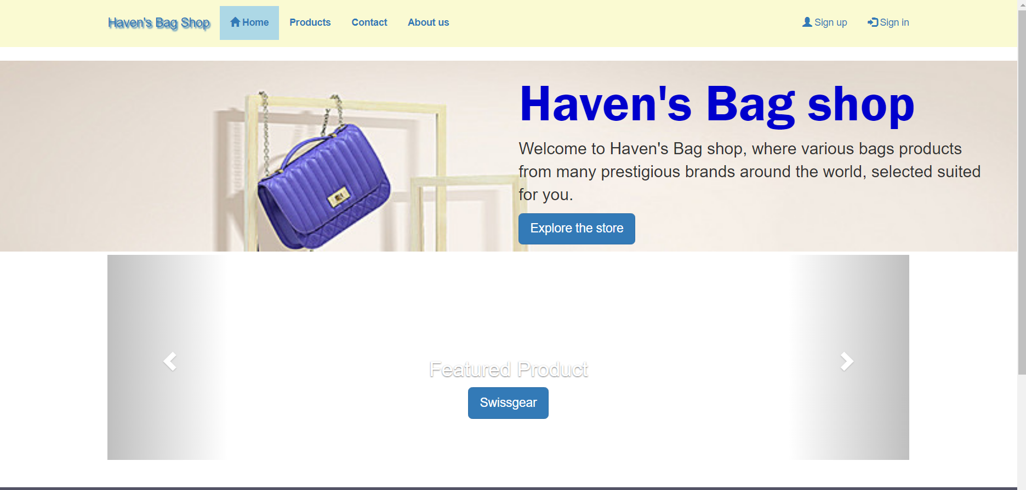

* **The main page of the shop. You will be greeted with the shop’s welcome message along with recommendation for the featured product, where you can navigate directly to it with just a click.**
* **You can also access many other pages of the shop through the navigation bar.**

1. **Admin Login:**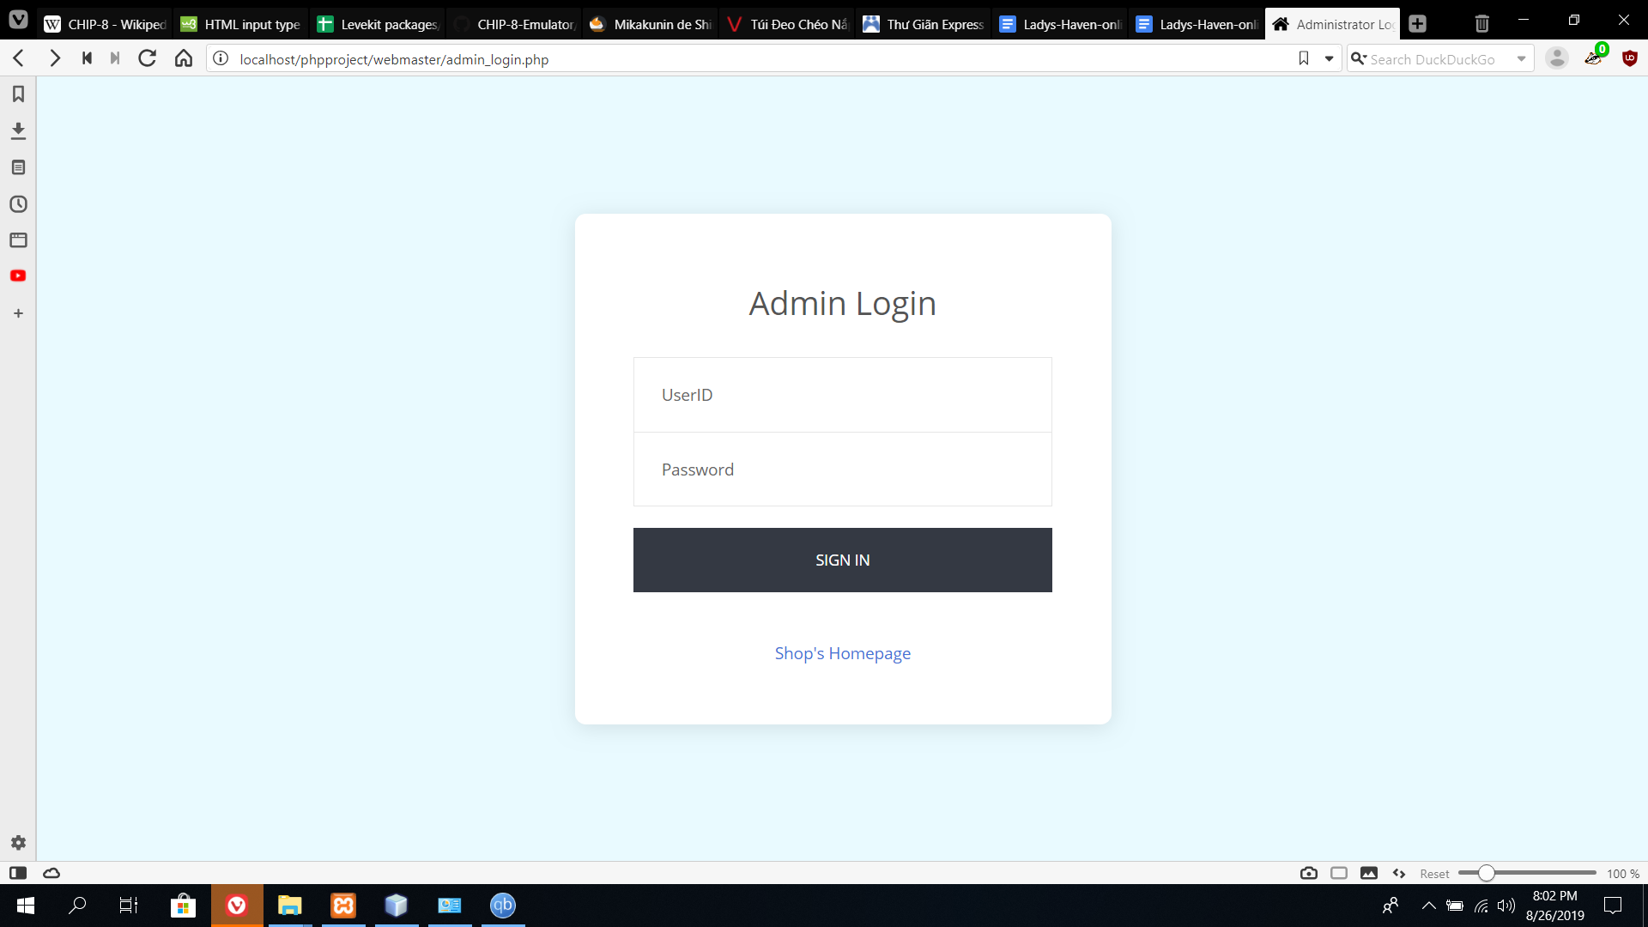

* **In this page, you can directly log into the administrator’s dashboard if you were given an access account by the webmaster, or you can go back to the Shop’s home page. This page will not be available to navigate to from any of the shop’s page. The admin will be given a fixed address that only him can get access to.**

1. **Admin’s Dashboard**

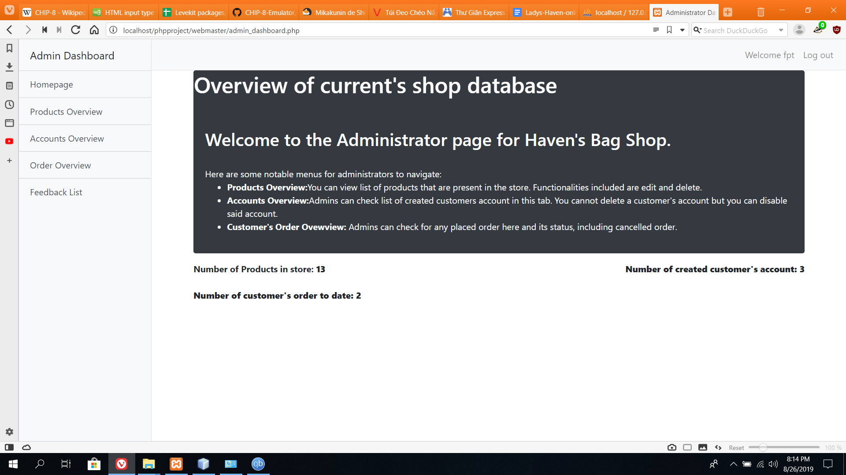

* **The main page of the administrator. Here the admin can navigate to other pages (Product’s Overview, Accounts’ Overview, Order Overview and Feedback List) to manage what’s happening between the client and the shop.**
  + **Product’s Overview:**

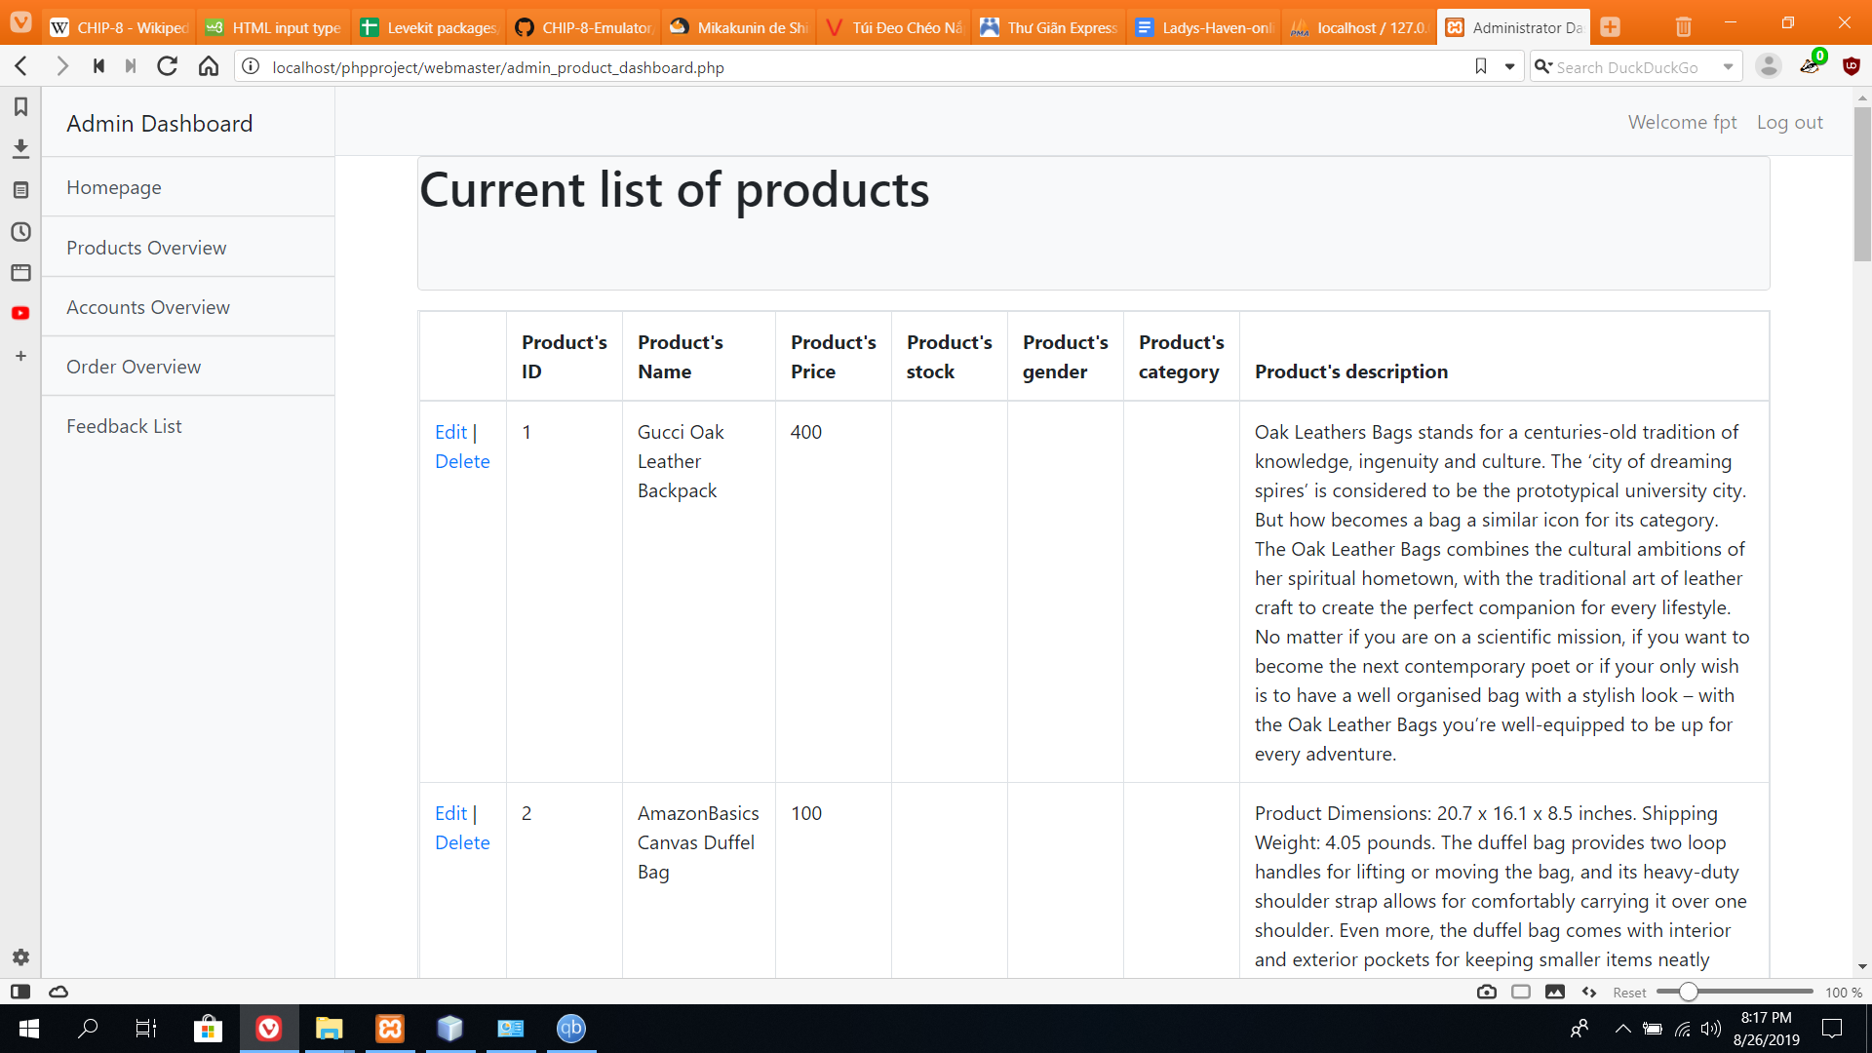

* **Admins can perform task such as edit a product from the catalog, delete it or create a new entry and add it to the database.**
* **Account’s overview:**

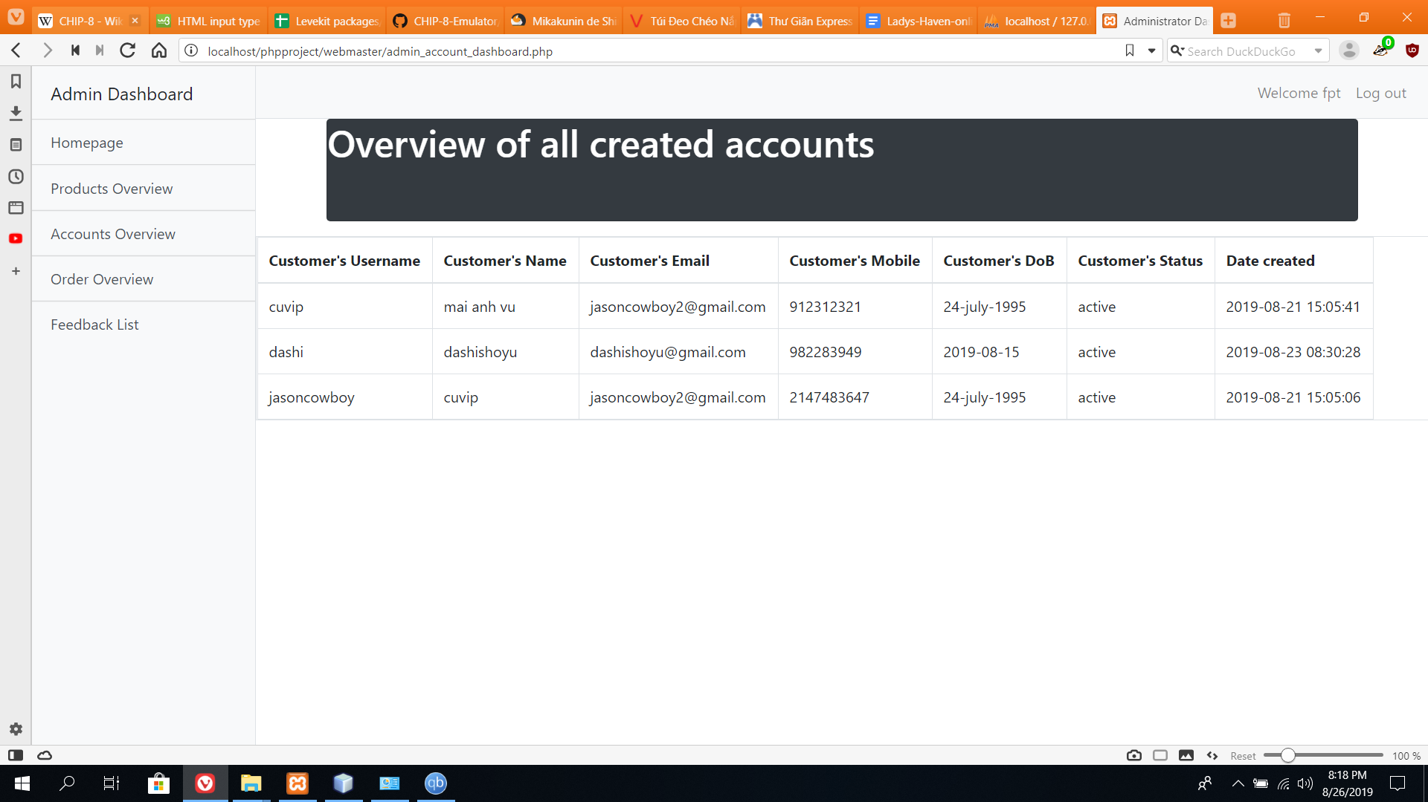

* **admin will be able to see a list of created accounts for the shop. He can also change the status of the account from active to disabled and vice versa.**
* **Feedback List:**

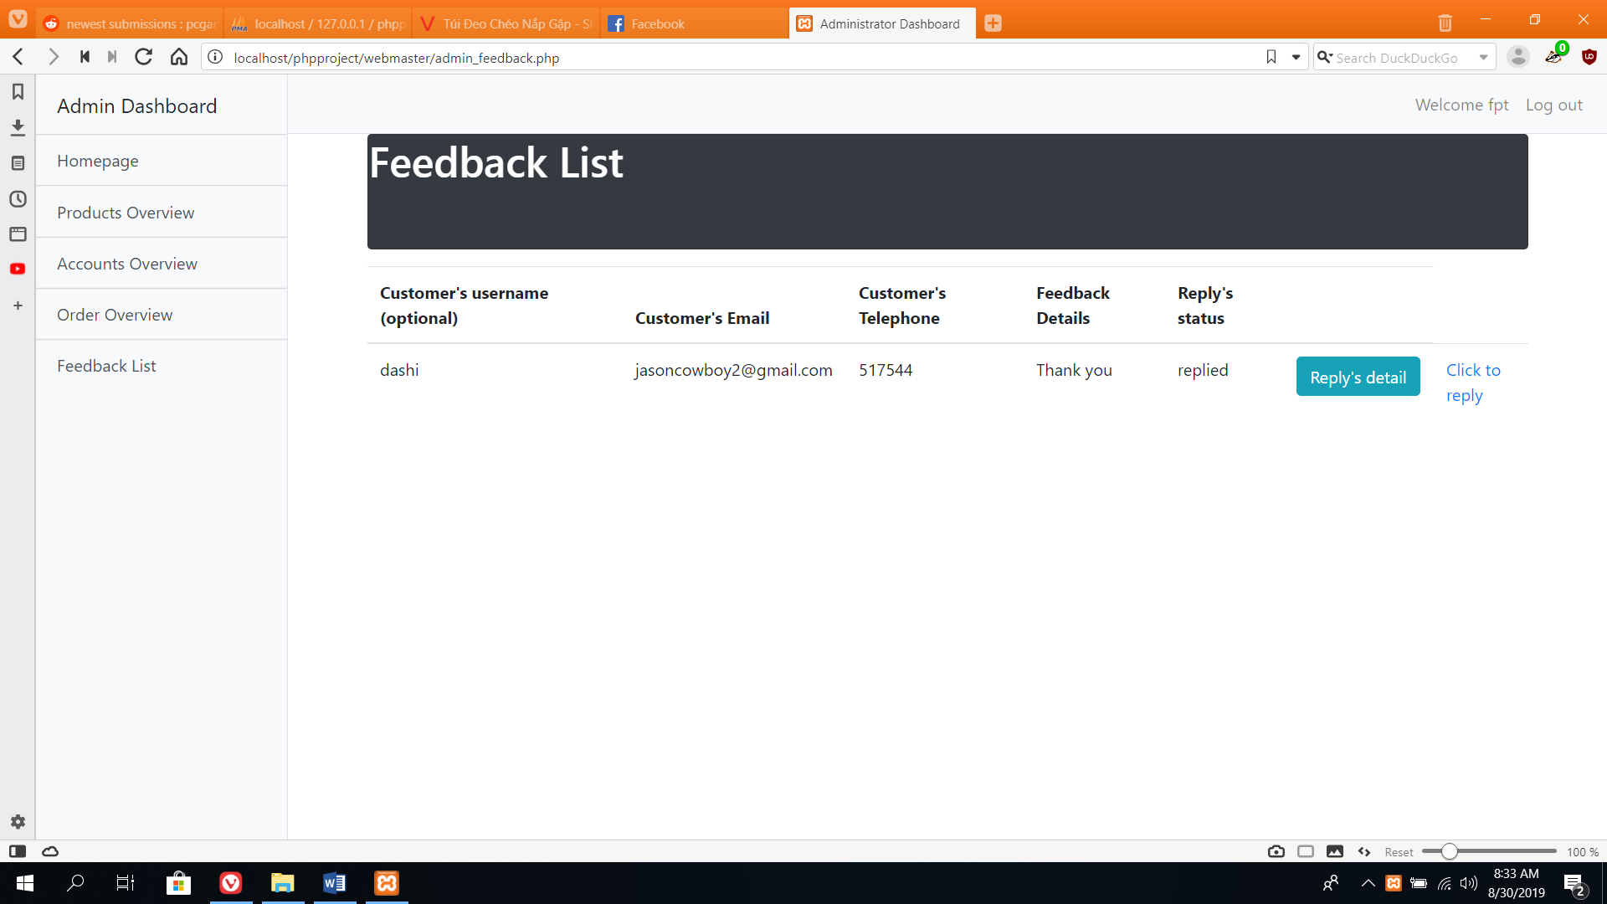

* **You can see a list of feedback given by the customer’s and the email provided, so that you can contact them and give a reply.**
* **You can also see the status of the feedback, and which admin has replied to it.**

1. **Product’s Page:**

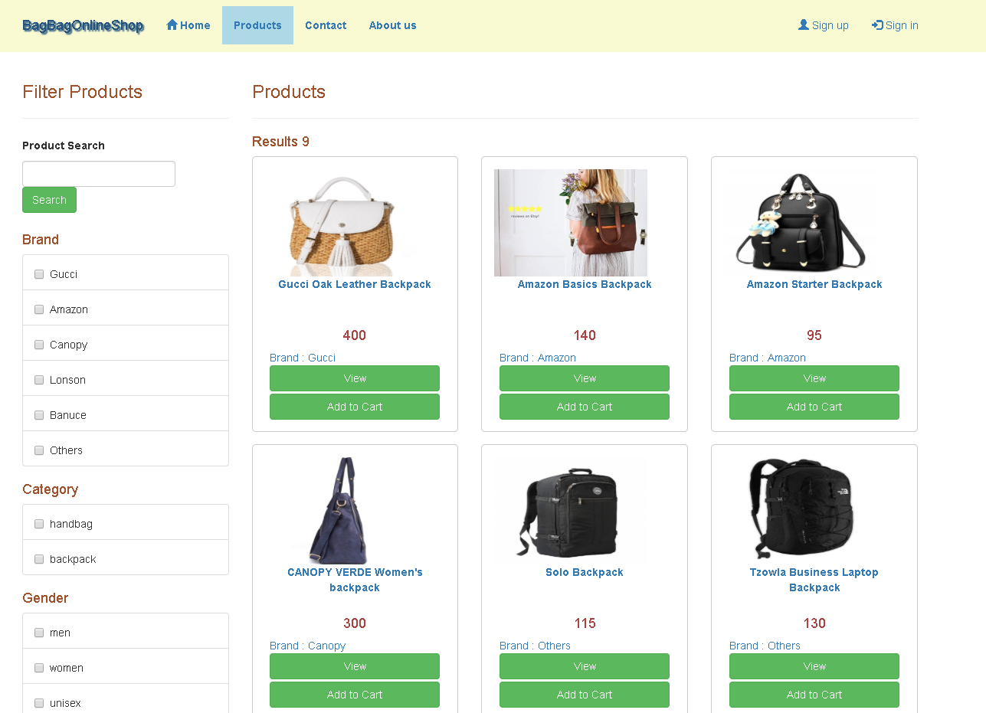

* **Within the product page, people will be able to browse through the catalog and make a purchase by adding the item to the shopping cart and proceed with their order.**

1. **Sign up**

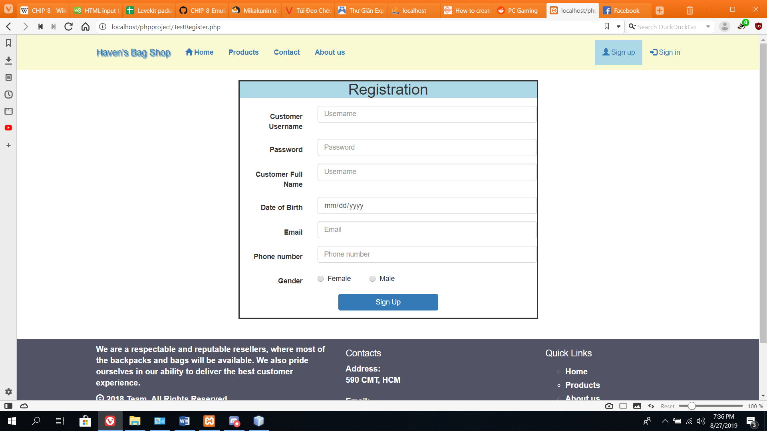

* **You can register your account, save your order and get special discount for members from time to time.**

1. **Sign in**

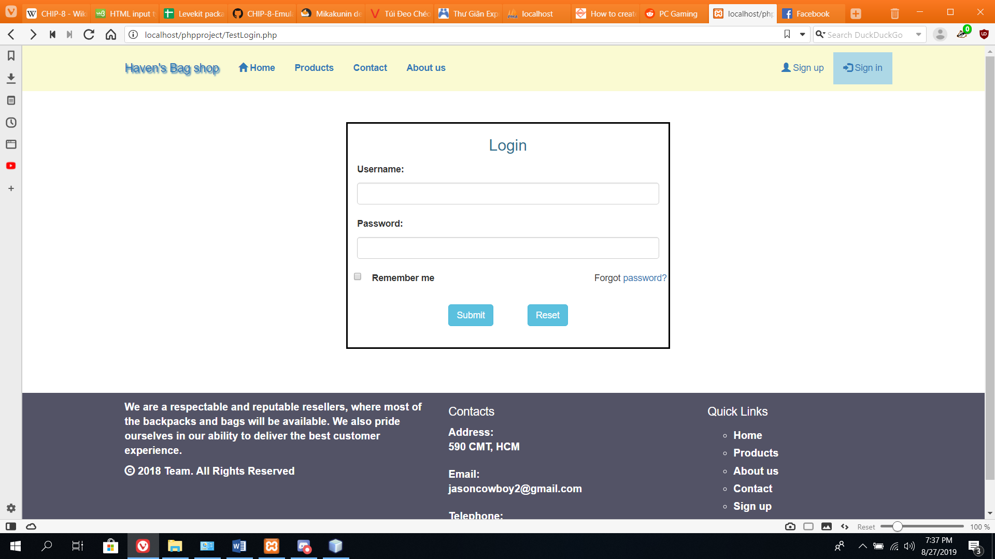

* **A login screen for member to log into their account.**

1. **User Account Profile**

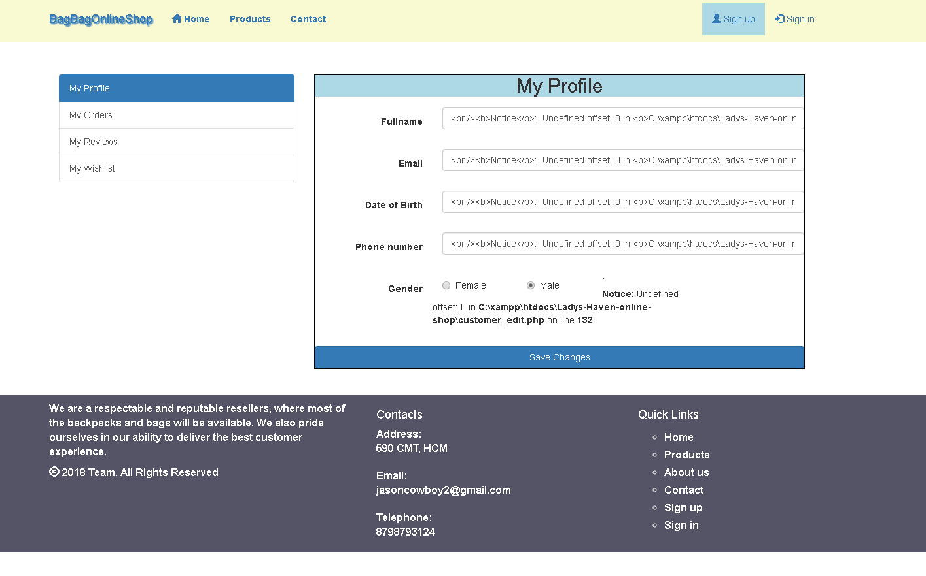

* **Upon successfully login, user will have the option to navigate to their account settings through the top right corner link. In this page, user will be able to check their wishlist, orders, their written product’s reviews and also edit their profile’s detail.**

1. **Cart Page.**

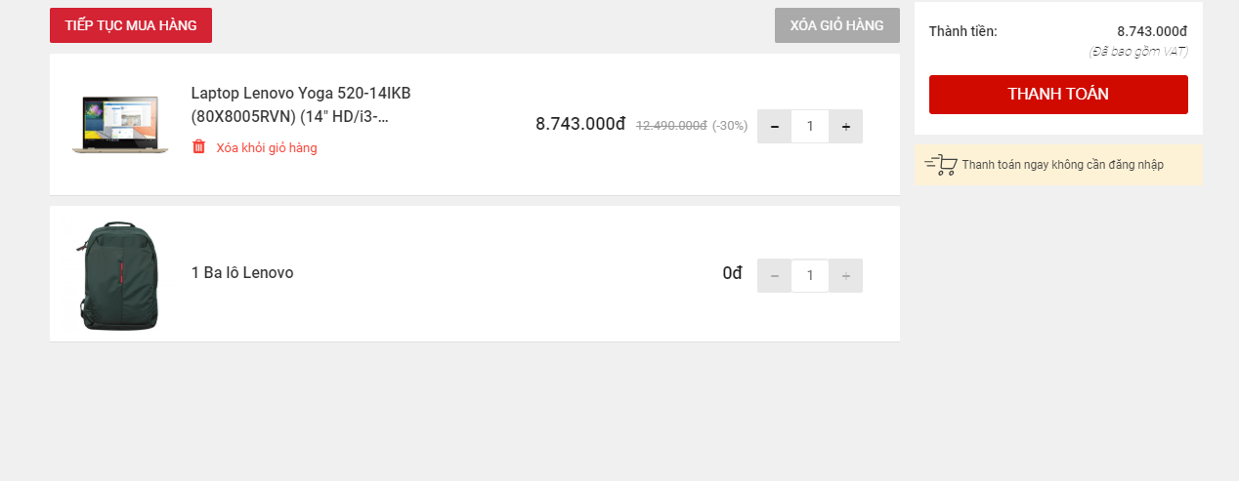

* **This is the cart page. Within this page, user will be able to check what they have chosen in their order so far. So they can either increase the order item number, or delete it from their order before making a final payment.**

1. **Contact:**

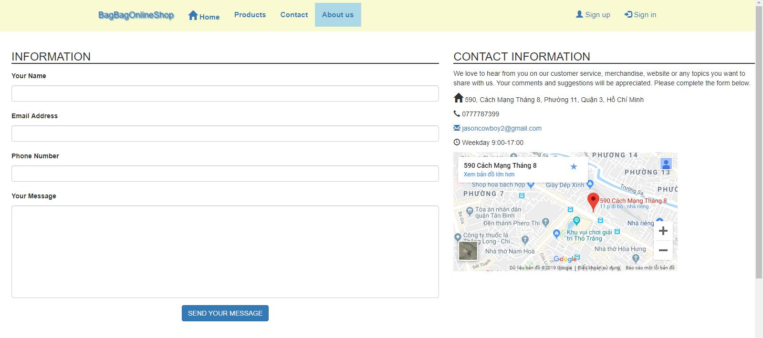

* **In this page, you can give the shop feedbacks and they’ll contact you through email.**

**TASK SHEET REVIEW 3**

|  |  |  |  |  |
| --- | --- | --- | --- | --- |
| **No.** | **Description** | **Begin Date** | **TeamMate Name** | **Notes** |
| 1 | Home | 15/2/2019 | Vu |  |
| 2 | Product | Quang |  |
| 3 | Contact us | Vu |  |
| 4 | About us | Vu |  |
| 5 | Sign up | An |  |
| 6 | Sign in | An |  |
| 7 | Product specific page | Quang |  |
| 8 | Admin Login | Vu |  |
| 9 | Admin Dashboard | Vu |  |
| 10 | Cart Page | Vu |  |
| 11 | User Profile |  | Quang |  |

|  |  |
| --- | --- |
| **Date:** | |
| Signature of Instructor:  **LE MONG THUY** | Signature of Team Leader:  **MAI ANH VU** |